**CURRICULUM VITAE**

**Swati Arun Chavan** 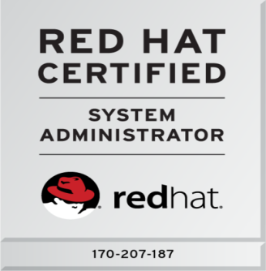

Email –swati23wagh@gmail.com

Mob No. – 7798413676 / 7798179626

Address - Sarthak Plot No. 8 SNo. 320/1, B/H - Jatra Hotel

Swami Samarth Nagar, Adgaon, Nashik-422003

**Career Objective:-**

I would like to be a part of an organization where I could use and enhance my knowledge and talent for the development of both the organization and myself.

**Technical Skills:-**

* Operating System : Windows , Red-hat Linux
* Languages : C, C++, .Net, SQL,HTML,CSS.
* Databases : MySQL, XAMP.

**Area of Interest:-**

* Linux System Administration.
* SQL development (Software Development).

**Academic Profile:-**

|  |  |  |  |
| --- | --- | --- | --- |
| **Course** | **Name of School / College** | **Board / University** | **Marks** |
| BE Computer | RHS GES COE, Nasik | Savitribai Phule University | 61.80% |
| HSC | R.Y.K. College, Nasik | State Board | 58.50% |
| SSC | Navarachna Vidyalaya | State Board | 84.15% |

**Training and Certification:-**

* Global Certification on Red Hat Linux (RHCSA)(CERTIFICATE NUMBER: 170-207-187)
* Completed training on Red Hat Linux (RHCE)
* Workshop on Cloud Computing
* Ajay Kamat’s Institute - .Net Course

**Work Experience:**

**Company Name: -** Shree Web Solution, Nasik.

**Designation: -** HTML CSS Designer as a trainee.

**Duration: -** 5 months.

**Company Name: -** APSC InfoTech and Software Solutions Pvt. Ltd., Nashik

**Designation: -** Technical Support Engineer.

**Duration: -** 1 year.

**Project Details:**

**Project Title: -** Quality Control of Printed Circuit Board using Image Processing.

**Sponsored by: - TAS PowerTek Pvt. Ltd.** Ambad MIDC, Nasik.

**Language Used: -** c#.Net

**Team Size: -** 4 Members

**Project Description: -** The main objective of this project is to develop an automated system for PCB testing and to detect faults in the PCB using Image Processing technique. So as to reduce manual human inspection time and to increase the quality of the PCBs.

**Advantages: -** Manual human inspection is replaced by automated testing and time of testing is reduced to large extend.

**Personal Assets:**

* Hardworking
* Ability to cope up with the changing environment
* Creative Mind
* Honest

**Achievements and Awards:**

* Participated in Math’s and drawing Competitions in School days activities.

**Personal Details:**

DOB : 23-05-1994

Marital Status : Married

Languages Known : English, Hindi and Marathi

Hobbies : Drawing, Making creative things.

**Declaration:-**

I hereby declare that above information is true to best of my knowledge.

|  |
| --- |
|  |

**(Swati Arun Chavan)**